DATA VALIDATION

DATA VALIDATION

# **HISTORICAL DATA**

## **EXCEL VS RAW_DB VS HAR_DB**

Row count for Meraki data in EXCEL - 184680

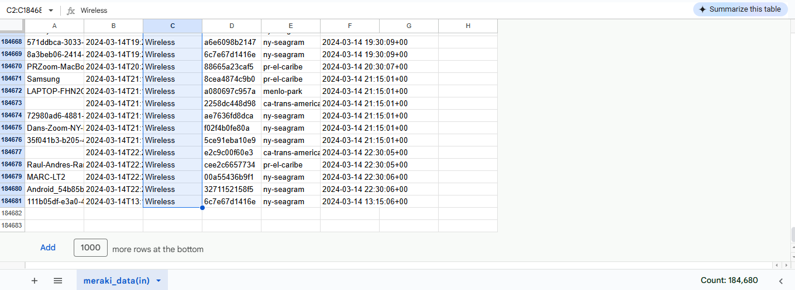

Row Count for meariki_historical table in RAW_DB - 184680

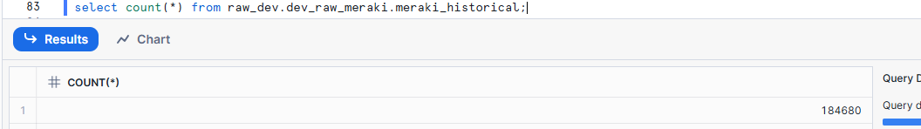

Audit

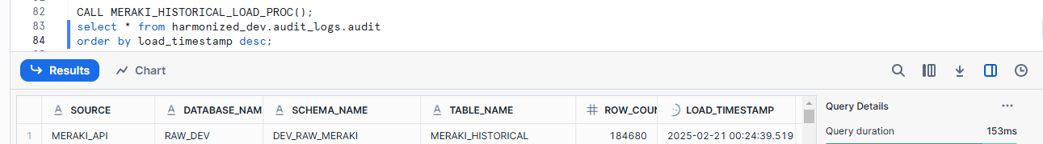

Data values in EXCEL



Data values in Snowflake

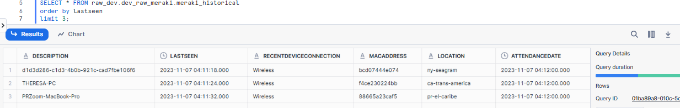

**Row Count for Meraki table in HAR_DB - 184680**

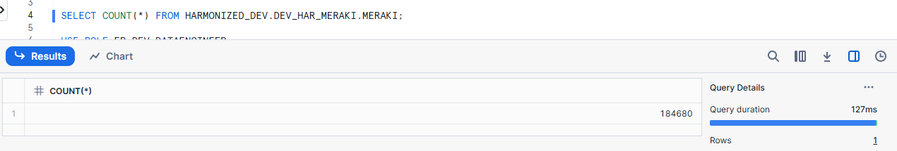

**Audit**

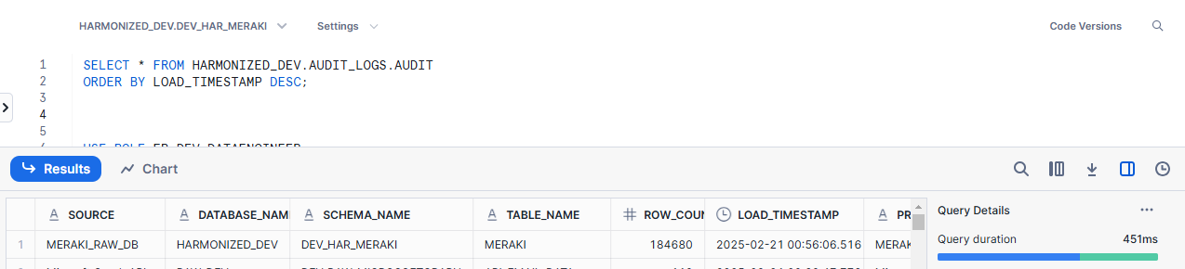

# **CONTINUOUS DATA**

## **POSTMAN VS RAW_DB**

## **Row count for San Francisco in Post man -**

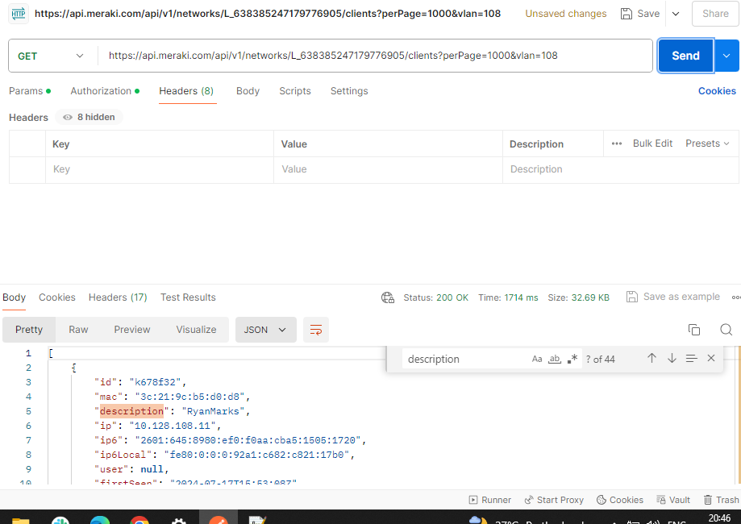

## **Row count for San Francisco in Snowflake-**

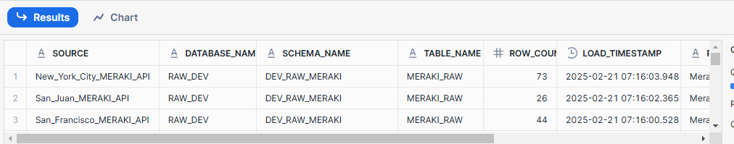

## **Row count for San Juan in Post man -**

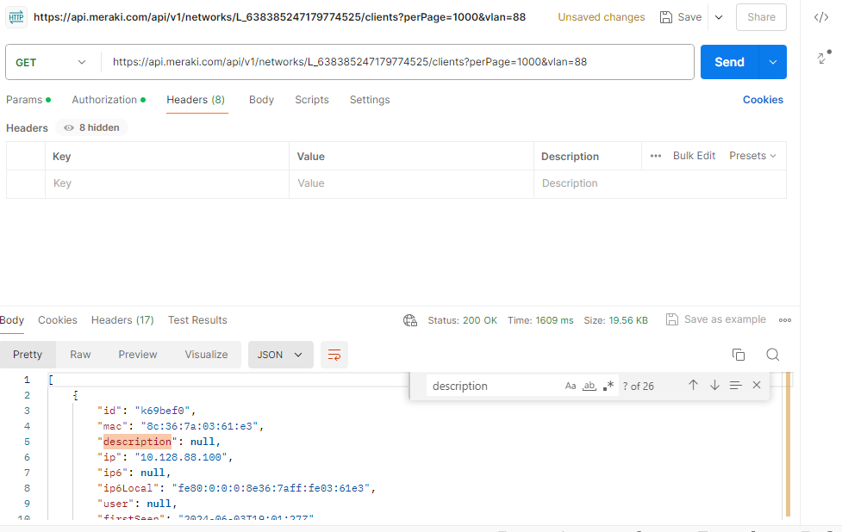

## **Row count for San Juan in Snowflake-**



## **Row count for New York City in Post man -**

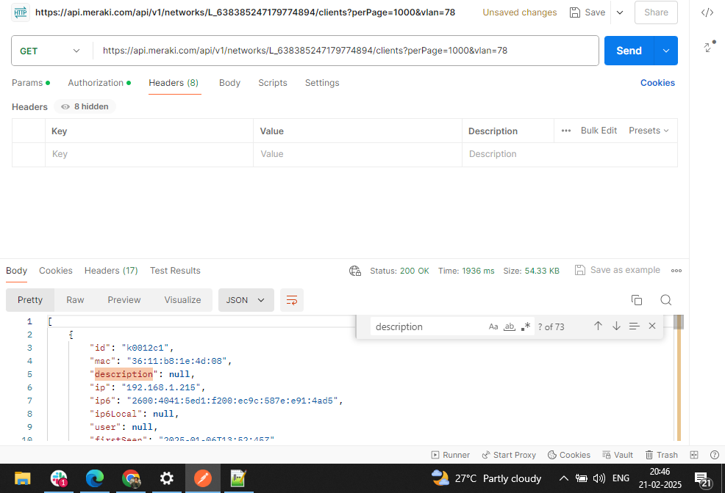

## **Row count for New York City in Snowflake**



## **DATA VALIDATION POSTMAN VS RAW_DB**

**San Francisco Data for id** k678f32 **in Postman**

"id": "k678f32",

"mac": "3c:21:9c:b5:d0:d8",

"description": "RyanMarks",

"ip": "10.128.108.11",

"ip6": "2601:645:8980:ef0:f0aa:cba5:1505:1720",

"ip6Local": "fe80:0:0:0:92a1:c682:c821:17b0",

"user": null,

"firstSeen": "2024-07-17T15:53:08Z",

"lastSeen": "2025-02-21T00:51:16Z",

"manufacturer": "Intel",

"os": null,

"deviceTypePrediction": null,

"recentDeviceSerial": "Q3AB-H9KY-YNYG",

"recentDeviceName": "TA- 45th Floor AP #1",

"recentDeviceMac": "e4:55:a8:13:e2:50",

"recentDeviceConnection": "Wireless",

"ssid": "Pantera_Secure",

"vlan": "108",

"switchport": null,

"usage": {

"sent": 1694,

"recv": 14398,

"total": 16093

},

"status": "Offline",

"notes": null,

"groupPolicy8021x": null,

"adaptivePolicyGroup": null,

"smInstalled": false,

"namedVlan": null,

"pskGroup": null,

"wirelessCapabilities": "802.11ax - 2.4 and 5 GHz"



**San Francisco Data for id in Snowflake**

adaptivePolicyGroup": null,

"description": "RyanMarks",

"deviceTypePrediction": null,

"firstSeen": "2024-07-17T15:53:08Z",

"groupPolicy8021x": null,

"id": "k678f32",

"ip": "10.128.108.11",

"ip6": "2601:645:8980:ef0:f0aa:cba5:1505:1720",

"ip6Local": "fe80:0:0:0:92a1:c682:c821:17b0",

"lastSeen": "2025-02-21T00:51:16Z",

"mac": "3c:21:9c:b5:d0:d8",

"manufacturer": "Intel",

"namedVlan": null,

"notes": null,

"os": null,

"pskGroup": null,

"recentDeviceConnection": "Wireless",

"recentDeviceMac": "e4:55:a8:13:e2:50",

"recentDeviceName": "TA- 45th Floor AP #1",

"recentDeviceSerial": "Q3AB-H9KY-YNYG",

"smInstalled": false,

"ssid": "Pantera_Secure",

"status": "Offline",

"switchport": null,

"usage": {

"recv": 14398,

"sent": 1694,

"total": 16093

},

"user": null,

"vlan": "108",

"wirelessCapabilities": "802.11ax - 2.4 and 5 GHz"



**San Juan Data for id in Postman**

"id": "k69bef0",

"mac": "8c:36:7a:03:61:e3",

"description": null,

"ip": "10.128.88.100",

"ip6": null,

"ip6Local": "fe80:0:0:0:8e36:7aff:fe03:61e3",

"user": null,

"firstSeen": "2024-06-03T19:01:27Z",

"lastSeen": "2025-02-21T15:28:02Z",

"manufacturer": "Palo Alto Networks",

"os": null,

"deviceTypePrediction": null,

"recentDeviceSerial": "Q4AV-S4NV-S33S",

"recentDeviceName": "PAN-SW-PR",

"recentDeviceMac": "a8:46:9d:ad:84:3e",

"recentDeviceConnection": "Wired",

"ssid": null,

"vlan": "88",

"switchport": "15",

"usage": {

"sent": 1997073,

"recv": 313787,

"total": 2310860

},

"status": "Online",

"notes": null,

"groupPolicy8021x": null,

"adaptivePolicyGroup": null,

"smInstalled": false,

"namedVlan": null,

"pskGroup": null,

"wirelessCapabilities": "802.11b - 2.4 GHz"



**San Juan Data for id in Snowflake**

"adaptivePolicyGroup": null,

"description": null,

"deviceTypePrediction": null,

"firstSeen": "2024-06-03T19:01:27Z",

"groupPolicy8021x": null,

"id": "k69bef0",

"ip": "10.128.88.100",

"ip6": null,

"ip6Local": "fe80:0:0:0:8e36:7aff:fe03:61e3",

"lastSeen": "2025-02-21T15:28:02Z",

"mac": "8c:36:7a:03:61:e3",

"manufacturer": "Palo Alto Networks",

"namedVlan": null,

"notes": null,

"os": null,

"pskGroup": null,

"recentDeviceConnection": "Wired",

"recentDeviceMac": "a8:46:9d:ad:84:3e",

"recentDeviceName": "PAN-SW-PR",

"recentDeviceSerial": "Q4AV-S4NV-S33S",

"smInstalled": false,

"ssid": null,

"status": "Online",

"switchport": "15",

"usage": {

"recv": 313787,

"sent": 1997073,

"total": 2310860

},

"user": null,

"vlan": "88",

"wirelessCapabilities": "802.11b - 2.4 GHz"

},



**New York City for id in Postman**

"id": "k0012c1",

"mac": "36:11:b8:1e:4d:08",

"description": null,

"ip": "192.168.1.215",

"ip6": "2600:4041:5ed1:f200:ec9c:587e:e91:4ad5",

"ip6Local": null,

"user": null,

"firstSeen": "2025-01-06T13:52:45Z",

"lastSeen": "2025-02-20T17:26:48Z",

"manufacturer": null,

"os": null,

"deviceTypePrediction": null,

"recentDeviceSerial": "Q3AB-ARJP-4UJQ",

"recentDeviceName": "PAN-AP-NY-RIGHT",

"recentDeviceMac": "e4:55:a8:12:f1:8d",

"recentDeviceConnection": "Wireless",

"ssid": "PanteraCapital",

"vlan": "78",

"switchport": null,

"usage": {

"sent": 18,

"recv": 0,

"total": 18

},

"status": "Offline",

"notes": null,

"groupPolicy8021x": null,

"adaptivePolicyGroup": null,

"smInstalled": false,

"namedVlan": null,

"pskGroup": null,

"wirelessCapabilities": "802.11b - 2.4 GHz"



**New York City for id in Snowflake**

"adaptivePolicyGroup": null,

"description": null,

"deviceTypePrediction": null,

"firstSeen": "2025-01-06T13:52:45Z",

"groupPolicy8021x": null,

"id": "k0012c1",

"ip": "192.168.1.215",

"ip6": "2600:4041:5ed1:f200:ec9c:587e:e91:4ad5",

"ip6Local": null,

"lastSeen": "2025-02-20T17:26:48Z",

"mac": "36:11:b8:1e:4d:08",

"manufacturer": null,

"namedVlan": null,

"notes": null,

"os": null,

"pskGroup": null,

"recentDeviceConnection": "Wireless",

"recentDeviceMac": "e4:55:a8:12:f1:8d",

"recentDeviceName": "PAN-AP-NY-RIGHT",

"recentDeviceSerial": "Q3AB-ARJP-4UJQ",

"smInstalled": false,

"ssid": "PanteraCapital",

"status": "Offline",

"switchport": null,

"usage": {

"recv": 0,

"sent": 18,

"total": 18

},

"user": null,

"vlan": "78",

"wirelessCapabilities": "802.11b - 2.4 GHz"

},



## **RAW_DB VS HARMONIZED_DB**

ROW COUNT FOR SAN FRANCISCO,SAN JUAN,NEW YORK CITY IN RAW_DB



ROW COUNT FOR SAN FRANCISCO IN HARMONIZED_DB

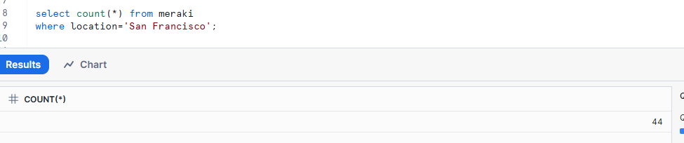

ROW COUNT FOR SAN JUAN IN HARMONIZED_DB

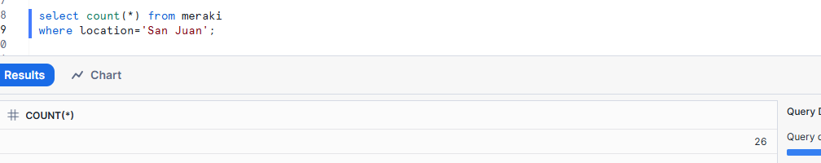

ROW COUNT FOR NEW YORK CITY IN HARMONIZED_DB

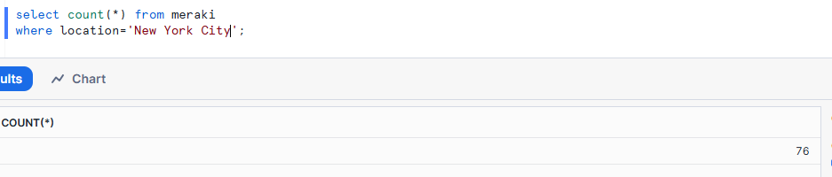

COLUMN COUNT FOR MERAKI_RAW IN RAW_DB - 30

COLUMN COUNT FOR MERAKI IN HAR_DB - 32

Got 2 extra columns named location, Attendance Date from Historical data.

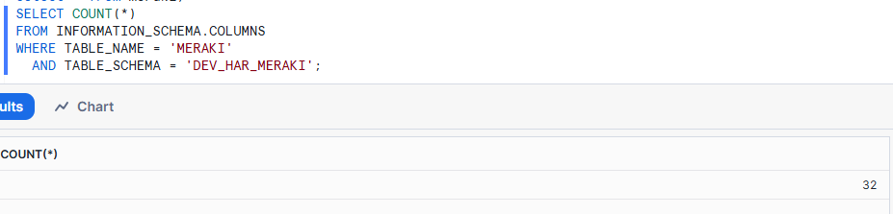

## **DATA VALIDATION FOR RAW_DB VS HARMONIZED_DB**

DATA FOR ID k722d7d IN RAW_DB

adaptivePolicyGroup": null,

"description": "Zoom-iPAD",

"deviceTypePrediction": "Apple iPad Mini, iOS16.5",

"firstSeen": "2023-06-12T19:05:43Z",

"groupPolicy8021x": null,

"id": "k722d7d",

"ip": "10.128.88.15",

"ip6": null,

"ip6Local": "fe80:0:0:0:1884:5080:6932:f8bb",

"lastSeen": "2025-02-21T15:42:45Z",

"mac": "ce:01:8d:14:84:e6",

"manufacturer": null,

"namedVlan": null,

"notes": null,

"os": "Apple iPhone",

"pskGroup": null,

"recentDeviceConnection": "Wireless",

"recentDeviceMac": "2c:3f:0b:f2:c7:01",

"recentDeviceName": "PAN-AP-PR",

"recentDeviceSerial": "Q3AB-D2V3-TLE7",

"smInstalled": false,

"ssid": "PanteraCapital",

"status": "Online",

"switchport": null,

"usage": {

"recv": 11424,

"sent": 1186,

"total": 12610

},

"user": null,

"vlan": "88",

"wirelessCapabilities": "802.11ac - 2.4 and 5 GHz"

},



DATA OR ID IN HAR_DB









## 